


Data Structure and Algorithms
Final Project

Project Title :
< Flight Management System >


Pilots :

- Majd Almubarak - 222429799
- Dania Abuhassnah - 222453425

- Atekah Aljafar - 222427138

Submitted to:
College of Computer Science and Information Technology
Dr. Fatema Rajeena

Date:
(December - 2023)

- Table of contents:

Title | Page
Abstract / Summary | 2
Introduction | 3
Problem statement | 3
methodology | 3
Results and discussion | 7
Conclusion | 11
References | 11

- Abstract / Summary :
The Flight Management System is a comprehensive solution for managing passenger information within the airline industry. It maintains records including passenger ID, passenger type (Business class, first class, or economy class).Passengers can purchase tickets by providing basic information such as name, passport number, ticket type, and payment details. The system supports ticket upgrades or downgrades post-purchase and allows passengers to print their information. With the capacity to handle a large number of passengers, the system enables the flight manager to efficiently search for passengers based on either passenger number or name, facilitating streamlined management and retrieval of passenger data.

- Introduction :
Flight Management System stands as a comprehensive and adaptive solution, catering to the multifaceted needs of the airline industry. With its capacity to handle large passenger volumes, support ticket modifications, and facilitate expedited data retrieval, the FMS emerges as an indispensable tool for modern airline operations.

- Problem Statement :
Is a simple airline management system that allows passengers to purchase tickets, upgrade or degrade their ticket class, and display their information. Additionally, flight managers can search for passengers by ID or name and display a list of all passengers.

- Methodology :

- Data structures used for the solution and why?
The data structure used in our C++ program is a linked list to manage passenger information. Specifically, we've implemented a singly linked list where each node of the list represents a passenger, and the Passenger struct holds the relevant information about each passenger.

Linked List :
The Passenger struct represents a node in the linked list. It contains information about a passenger (name, address, etc.) and a pointer (link) to the next passenger in the list.
The linked list is created and managed using pointers (head, tail, temp, cur). head points to the first node, tail points to the last node, temp is used for creating new nodes, and cur is a temporary pointer used for traversing the list.

Dynamic Memory Allocation :
new Passenger is used to dynamically allocate memory for a new passenger node. This allows you to create nodes as needed during runtime.

The use of a linked list is suitable for this scenario because it provides efficient insertion and deletion operations, which are common when managing a list of passengers. Additionally, dynamic memory allocation allows you to manage memory more efficiently, allocating memory only when needed.

- Algorithm :
The program uses a menu-driven approach to interact with the user, allowing them to choose between being a flight passenger or a flight manager.
Nested menu structures are employed for passenger and manager services.

Main Menu :
1-Flight Passenger: Accesses the passenger menu.
2-Flight Manager: Accesses the manager menu.
3-Exit: Exits the program.

Passenger Service Algorithm :
The PassengerService function handles the passenger-related operations based on the user's choice (Purchase a ticket, Upgrade/Degrade a ticket, Display passenger information).
Specific functions (PurchaseATicket, UpgradeOrDegradeTicket, DisplayPassengerDetails, Go back to the main menu) are called based on the user's choice.

Manager Service Algorithm :
The ManagerService function handles the manager-related operations based on the user's choice (Search passenger by number, Search passenger by name, Display all passengers).
Specific functions (SearchPassengerByNumber, SearchPassengerByName, displayAllPassengers, Go back to the main menu) are called based on the user's choice.

Passenger Purchase Ticket Algorithm :
The PurchaseATicket function allows a passenger to enter their details, including ID, name, passport number, phone number, address, ticket number, and ticket degree.
It validates the entered ID to ensure uniqueness, and based on user input, assigns a ticket degree to the passenger.

Display Passenger Details Algorithm :
The DisplayPassengerDetails function prompts the user to enter their ID and searches the linked list for the corresponding passenger.
If found, it displays the details of that passenger.

Search Passenger Algorithm :
Both SearchPassengerByNumber and SearchPassengerByName functions search for a passenger based on the entered ID or name, respectively.
They traverse the linked list and display the details if a match is found.

Upgrade/Degrade Ticket Algorithm :
The UpgradeOrDegradeTicket function allows a manager to upgrade or degrade a passenger's ticket degree.
It displays the current ticket degree and prompts the manager to choose a new degree.

Display All Passengers Algorithm :
The displayAllPassengers function traverses the linked list and displays details for all passengers.

ID_Validation :
Validates if a given Id already exists in the system

Overall, the algorithmic structure revolves around handling user input, manipulating the linked list based on user choices, and displaying relevant information. The use of functions helps modularize the code and makes it more readable and maintainable.

- Executable Program Code:

- Results and discussion :
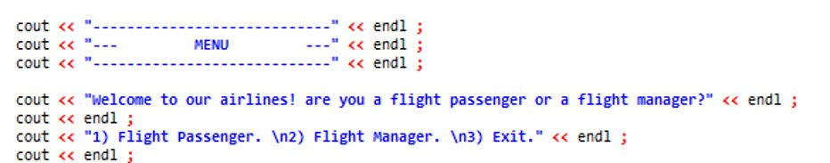
The first thing you will see is a menu that asks whether you are a flight passenger, a flight manager, or if you want to exit the program.

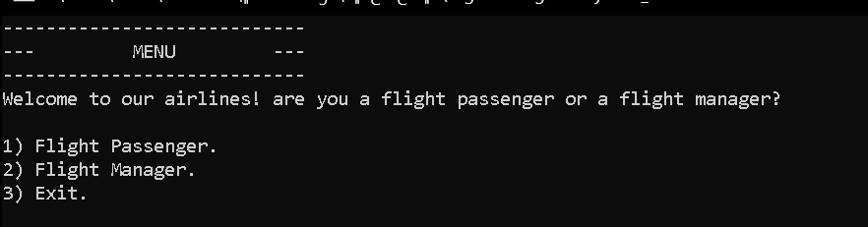

Passenger Menu :
Purchase a ticket: Allows passengers to input their details and purchase a ticket, including selecting the ticket class.
Valid Input:
Enter a unique ID that is not already in use.
Provide a name, passport number, phone number, address, and ticket number.
Choose a ticket degree by entering 1, 2, or 3 based on your options.
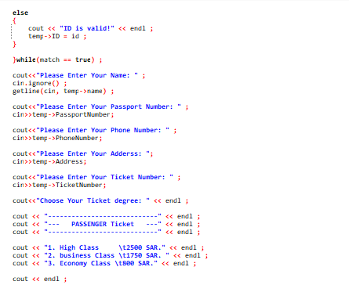
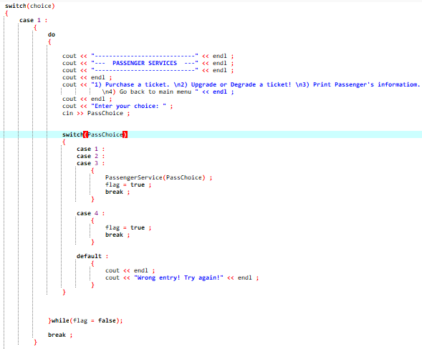

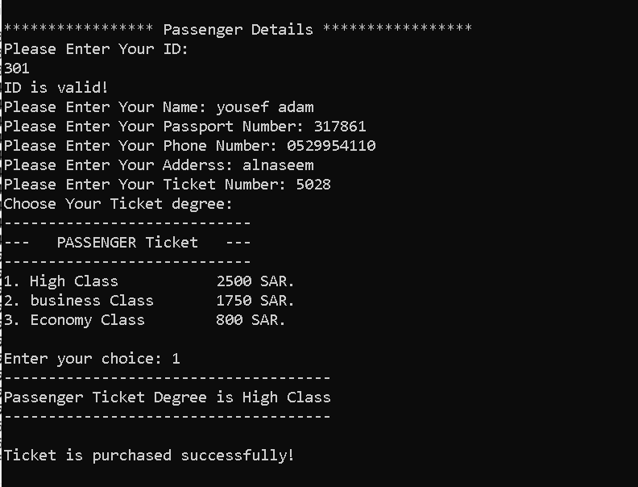
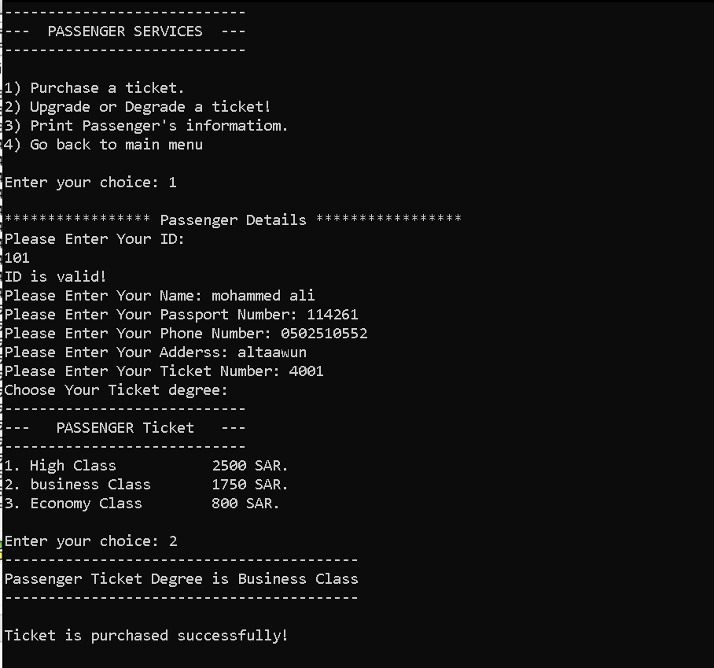

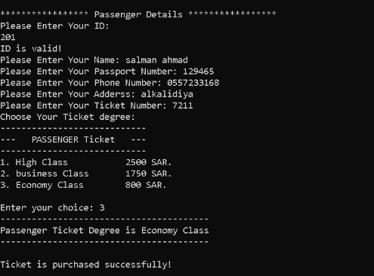

Invalid ID Input:
Enter an ID that already exists. This will trigger the ID validation mechanism in your program.
Cancel Purchase:
Choose to cancel the purchase when prompted after entering a duplicate ID.
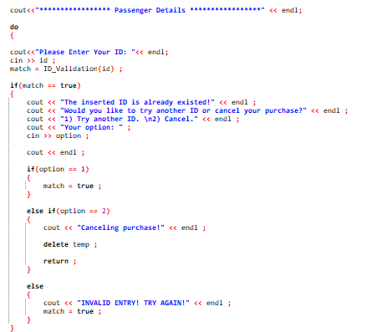
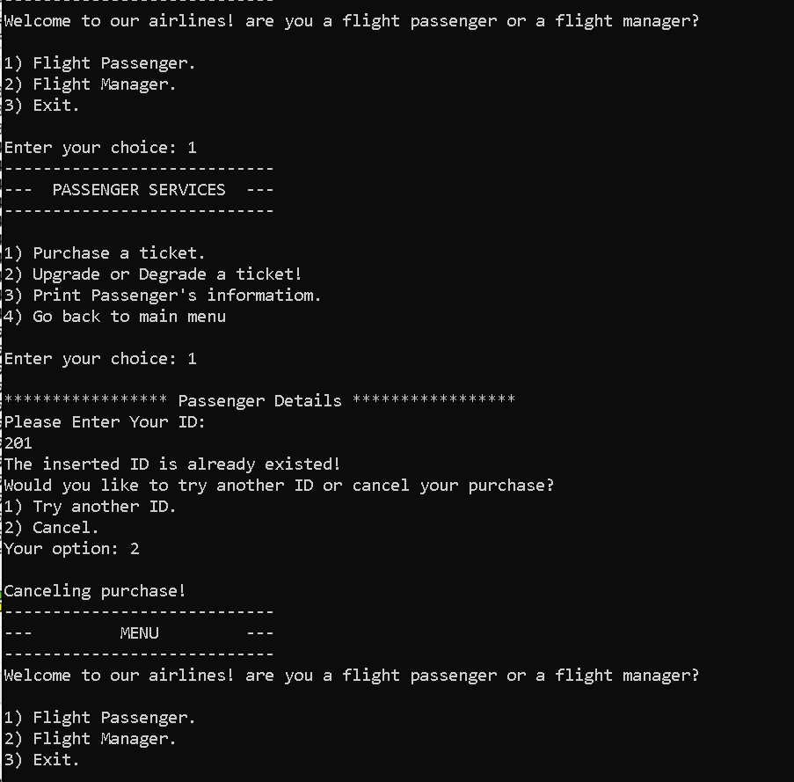

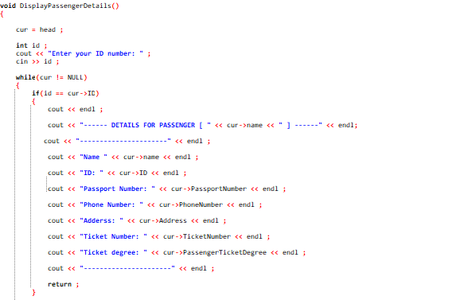
Print Passenger's Information: Displays details of a specific passenger based on their ID.
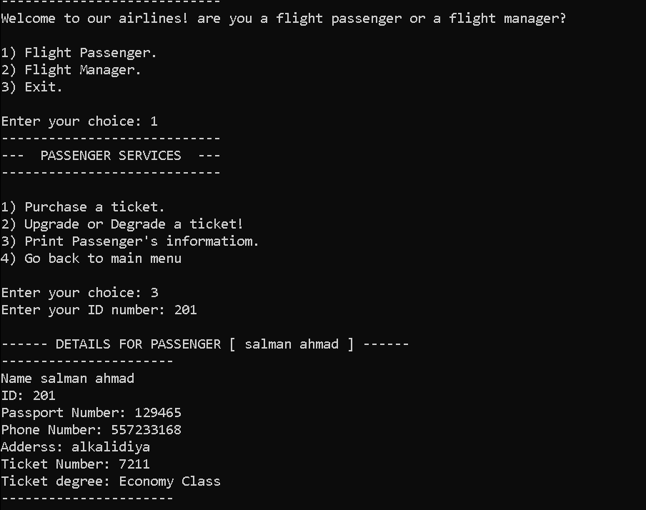

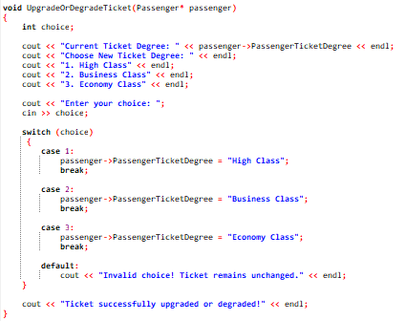
Upgrade or Degrade a ticket: Allows passengers to change their ticket class.
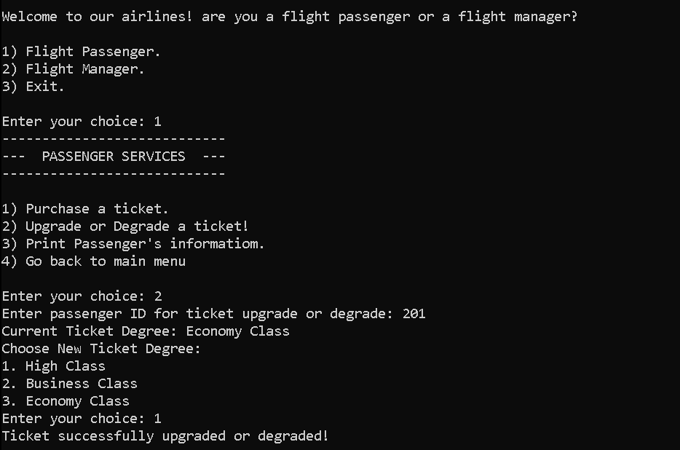
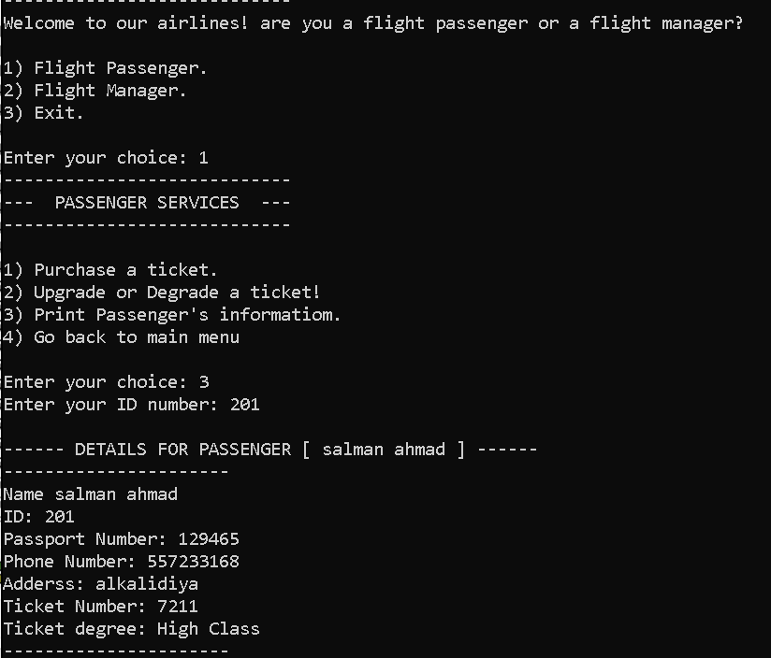

Go back to the main menu: Returns to the main menu.
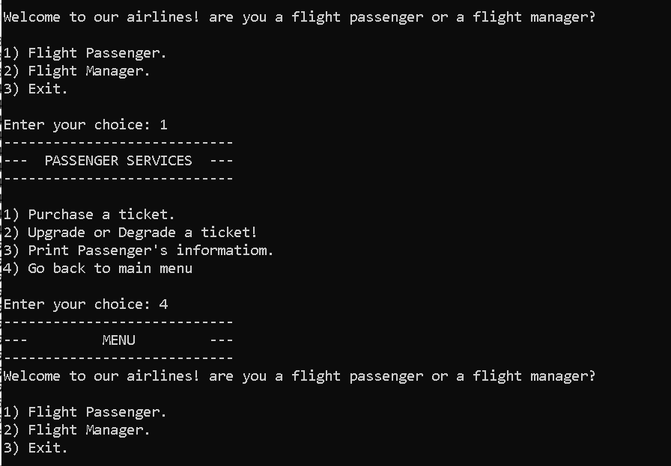
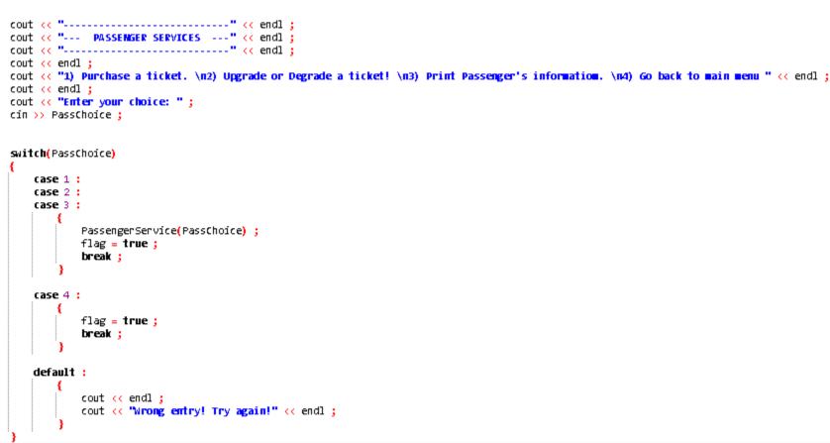

Flight Manager
The program prompts the Flight Manager to choose from different options, such as searching for a passenger by ID, searching for a passenger by name, displaying all passengers, or going back to the main menu.
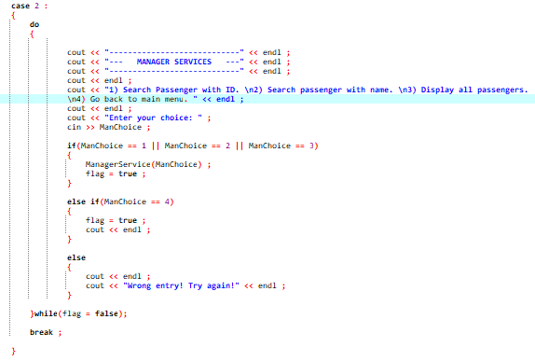

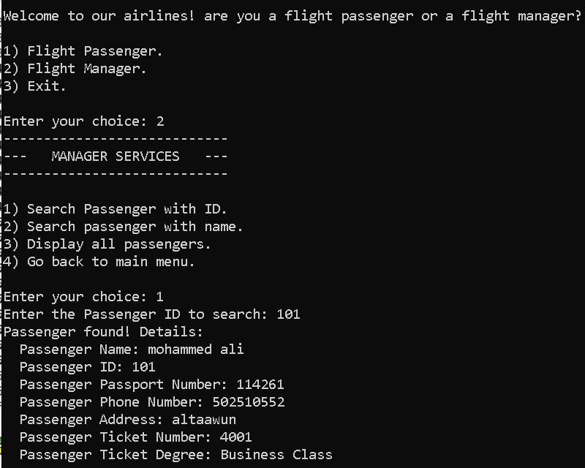

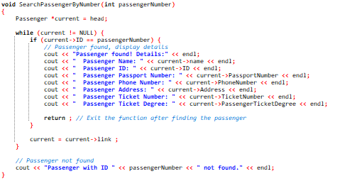
Search Passenger with ID: Allows managers to search for a passenger by their ID and display their information.
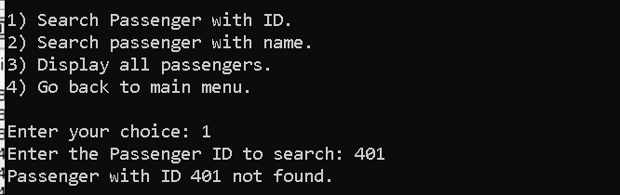


Search passenger with name: Allows managers to search for a passenger by their name and display their information.
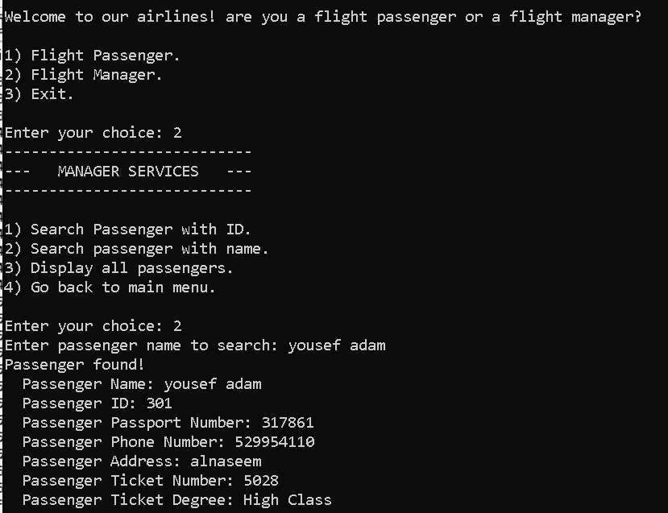
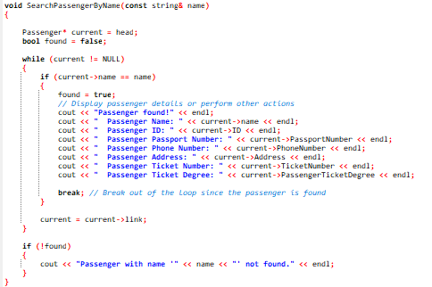

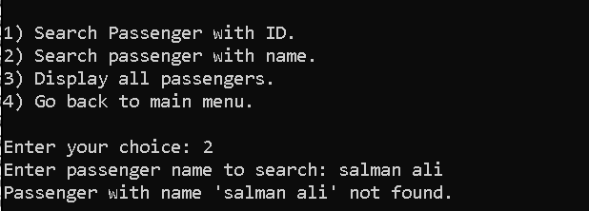

Display all passengers: Displays information for all passengers.

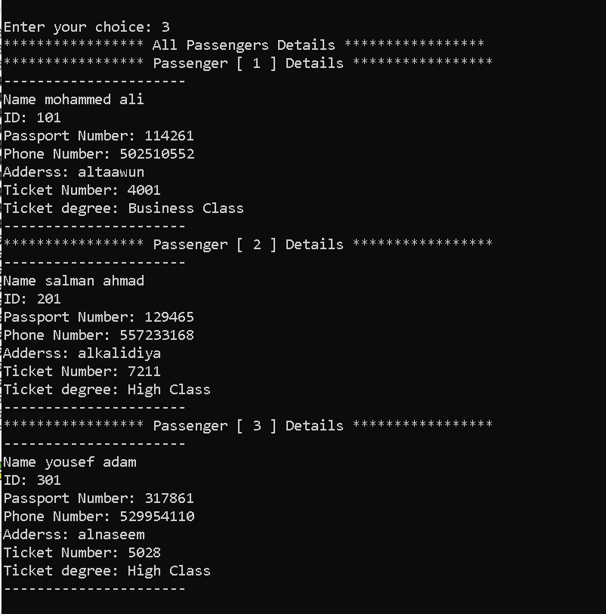
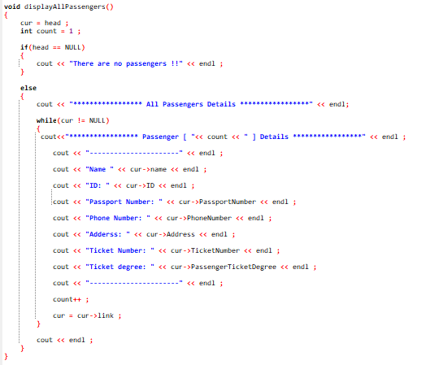

Exit: Exits the program.
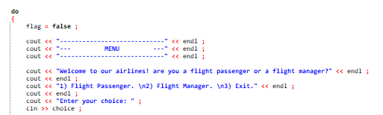
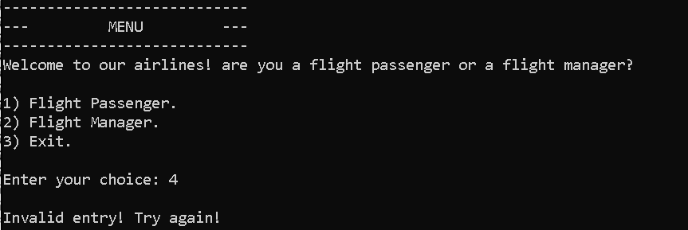
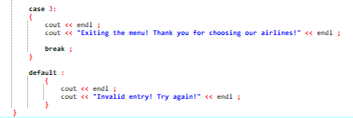
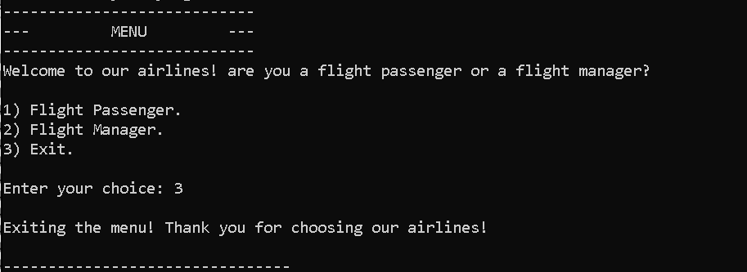

- Conclusion :
All in All, the development of this Airline Management System marks a significant stride in improving the efficiency and organization of airline operations. The program employs a linked list data structure to adeptly manage passenger details, fostering smooth interactions between passengers and managers. Through a menu-driven approach, the system accommodates a range of functionalities for both passengers and managers, including ticket purchasing, upgrades or downgrades, and comprehensive searches. The modular and readable code structure, coupled with effective error handling, contributes to a user-friendly experience. As the program leverages dynamic memory allocation and tailored algorithms, it exemplifies the potential of innovative solutions in simplifying and enhancing the management of airline services.

- References :
Data Structures and Algorithms in C++

